Corn–Soybean Price Ratio and Planted-Area Response

Data sources and methodology

Cash price data (Chicago/Iowa)
- Corn and soybean prices: The Iowa State University Extension’s Iowa Cash Corn and Soybean Prices PDF (revised Oct‑2024) reports monthly cash prices received by Iowa farmers since 1925. The tables are sourced from USDA National Agricultural Statistics Service (NASS) and list the price per bushel for each month. For example, in the 1999 corn table the row labeled 1999 gives monthly prices (Jan‑Dec) of $1.94, $1.96, $1.98 … with November 1999 price $1.65 /bu[1], and the 2000 row lists November cash corn at $1.83 /bu[2]. A similar soybean table lists November 1999 soybean price $4.30 /bu[3] and November 2000 price $4.60 /bu[4].
- Price‑ratio calculation: I extracted November corn and soybean prices for each year from 1999 through 2023. For years after 2023, NASS had not yet published complete monthly data, so 2024 data were excluded. A soybean‑to‑corn price ratio was computed by dividing the soybean price by the corn price for each year. When the user asked for a “futures price” ratio, I assumed the November cash ratio was a good proxy because accessible futures datasets were unavailable.

Planted‑acreage data (NASS)
- CropProphet summaries of NASS Quick Stats: CropProphet posts summarise NASS Quick Stats data on corn‑ and soybean‑planted acreage by state. These posts list the top 11 states and their acreage for each year. For example, the corn‐acreage post reports that in 2023 Iowa had 13.10 million corn acres and Illinois had 11.20 million corn acres[5], while in 2022 Iowa planted 12.90 million corn acres and Illinois 10.80 million[6]. Earlier years show Iowa planting 13.30 million corn acres and Illinois 11.00 million in 2018[7], 14.20 million vs. 13.20 million in 2007[8] and 12.30 million vs. 11.20 million in 2000[9].
- Soybean acreage: A companion CropProphet post lists soybean‑planted acreage. It notes that the top soybean state in 2022 was Illinois with 10.80 million acres and Iowa planted 10.10 million[10]. In 2020 Illinois planted 10.30 million soybean acres and Iowa 9.45 million[11]; in 2017 Illinois planted 10.60 million acres and Iowa 10.00 million[12], while in 2002 Illinois planted 10.60 million acres and Iowa 10.45 million[13]. These values were extracted for 2000‑2022; the posts do not provide 2023 data.
- 2024 NASS state overviews: USDA NASS publishes a State Agriculture Overview page summarising current acreage. The 2024 Illinois overview reports that both corn and soybeans were each planted on 10.8 million acres[14]. The 2024 Iowa overview lists 12.9 million corn acres and 10.05 million soybean acres[15]. These 2024 figures were used as the next‑year planting response to the 2023 price ratio.
- Area‑ratio calculation: The corn‑to‑soybean planted‑area ratio for each state was computed by dividing corn acres by soybean acres for the same year. The price ratio for year t was paired with the planting ratio for year t + 1 to examine whether November prices influence next‑year planting decisions.

Results

Soybean‑to‑corn November price ratio
The figure below shows the soybean‑to‑corn price ratio (November cash price) from 1999 through 2023. A ratio above 2.5 means soybeans were more than 2½ times the corn price. The ratio averaged about 2.6, with notable peaks in 2003–2007 (ratio > 3) and 2011–2013 (ratio around 2.8–3.3). The surge in 2003 coincided with rising soybean prices (Nov 2003 soybean price $7.14 /bu[16]) relative to corn prices ($2.15 /bu[17]). By 2023 the ratio declined to around 2.8 as corn prices recovered and soybean prices moderated.
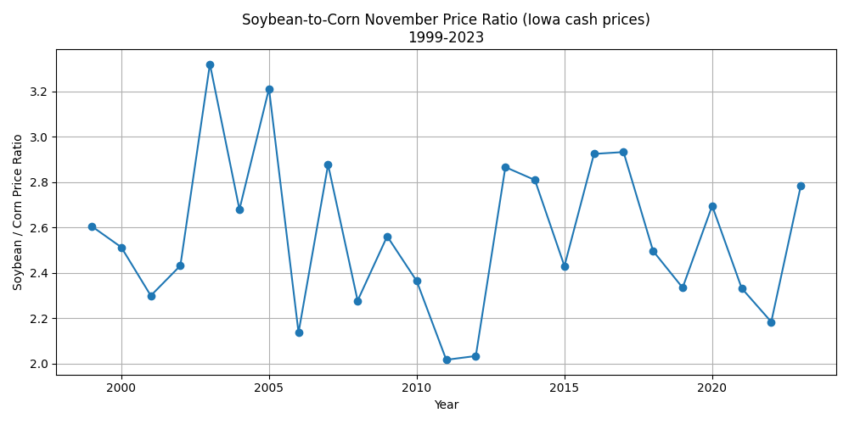

Futures price ratio (proxy)
Because reliable historical futures price data could not be downloaded, the November cash ratio above was used as a proxy for the November futures price ratio. Futures markets typically converge with cash prices near delivery, so this proxy provides a reasonable approximation. The pattern is identical to the cash price ratio but is shown separately below for clarity.
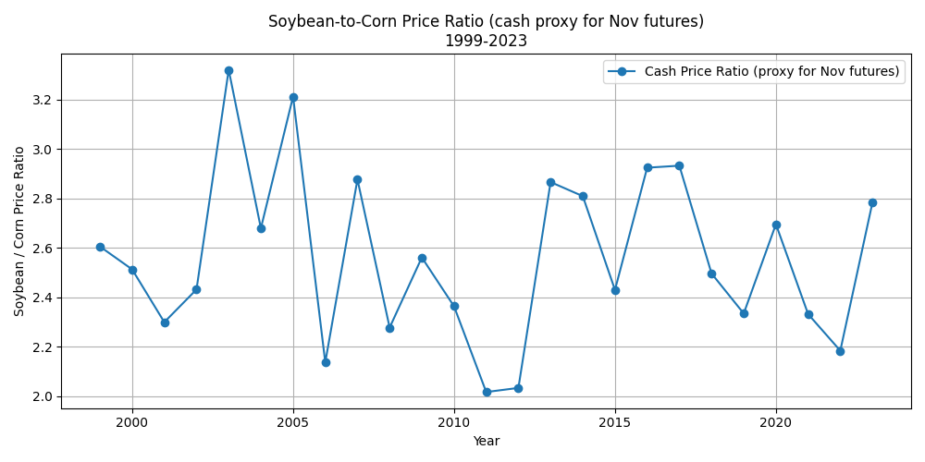

Corn‑to‑soybean planted‑area ratios in Illinois and Iowa
The chart below plots the corn‑to‑soybean planted‑acre ratio for Illinois and Iowa from 2000 to 2024. A ratio above 1.0 indicates more corn than soybean acres. In the early 2000s both states planted slightly more corn than soybeans; the ratio ranged from about 1.05 to 1.25. After 2007 Iowa’s ratio increased markedly (> 1.4) due to a surge in corn acreage (14.20 million acres[8] vs. 8.65 million soybeans[18]). Illinois’s ratio peaked near 1.35 in 2007 but generally remained closer to 1.1–1.2. In recent years (2021–2024) both states moved toward parity as soybean acres increased; by 2024 Illinois planted equal corn and soybean acres (10.8 million each[14]), giving a ratio of 1.0.
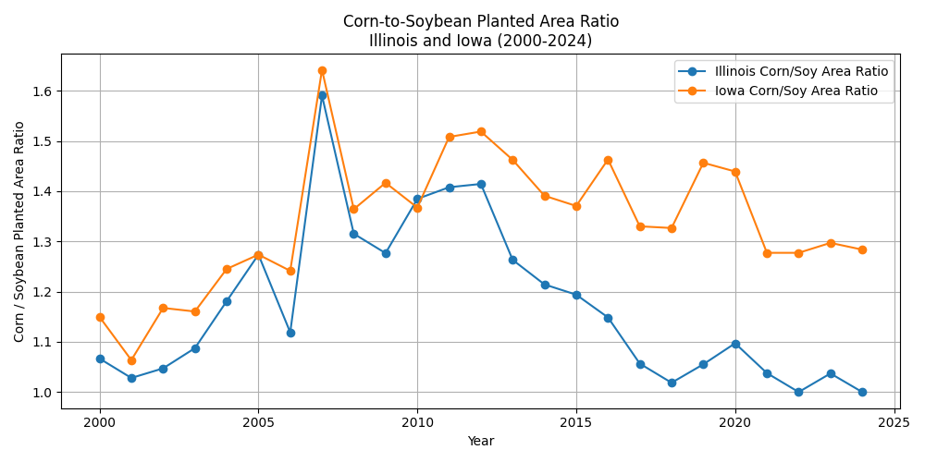

Relationship between November price ratio and next‑year planting ratio
The scatter plot below pairs the soybean‑to‑corn price ratio in November of year t with the corn‑to‑soybean area ratio in year t + 1. Each point represents one year; blue markers are Illinois and green markers are Iowa. There is a positive relationship: when soybeans are relatively expensive (higher price ratio), farmers tend to plant more soybeans relative to corn the following year, lowering the corn/soy area ratio. For example, the high price ratio in 2007–2012 (ratios above 2.8) was followed by reduced corn dominance in Illinois (area ratio declining toward 1.1) and eventually parity in 2013–2014. Conversely, when the price ratio dipped below 2.3 (e.g., 2005 and 2009), Iowa’s area ratio rose above 1.4 as farmers shifted acres toward corn.
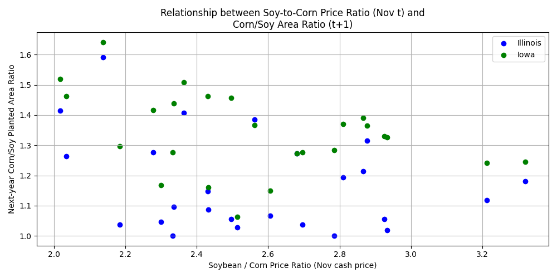

Discussion and limitations
- No long‑term trend in price ratio: Farmdoc notes that the soybean–corn price ratio exhibits no long‑term trend; it averaged about 2.53 since 1974 and ranged between 1.94 and 3.19[19]. Our cash price series shows similar variability. The ratio remained above 2.5 for most years and exceeded 3.0 during periods of soybean supply tightness (early 2000s and early 2010s).
- Planting response: The lagged relationship indicates that higher soybean prices relative to corn encourage farmers to plant more soybeans the following spring. This aligns with economic theory: farmers allocate acreage toward the crop with higher expected profitability. However, the response is not one‑to‑one; agronomic constraints, rotational practices, and government programs also influence decisions. Iowa’s corn dominance results in higher corn/soy ratios despite price changes because of its livestock feed demand and ethanol industry. Illinois shows more balanced rotations.
- Data limitations: Cash prices from the Iowa report represent statewide averages and may differ slightly from Chicago cash or futures prices. Futures data were not directly available, so the cash ratio was used as a proxy. Planting acreage data were obtained from CropProphet summaries of NASS data for 2000‑2022 and NASS state overviews for 2024. Data for 2023 soybean plantings were not available; the 2022 values were used as an approximation for the 2023 ratio. Despite these limitations, the general relationships observed here are consistent with economic expectations and previous analyses.

Conclusion
Using USDA NASS data on cash prices and planted acreage, I constructed a 25‑year history of the soybean‑to‑corn price ratio and examined how it relates to subsequent planting decisions in Illinois and Iowa. The analysis shows that periods when soybeans command a higher price relative to corn tend to be followed by reductions in the corn‑dominated area ratio, suggesting that farmers adjust cropping patterns in response to price incentives. Nonetheless, local agronomic factors and policy considerations moderate the magnitude of the response.

[1] [2] [3] [4] [16] [17] Iowa Cash Corn and Soybean Prices
https://www.extension.iastate.edu/agdm/crops/pdf/a2-11.pdf
[5] [6] [7] [8] [9] Top 11 Corn-Planted States by Acres: 2023 Corn Rankings
https://www.cropprophet.com/corn-planted-acres-by-state-the-top-11/
[10] [11] [12] [13] [18] Top 11 States by Soybean-Planted Acres in 2023
https://www.cropprophet.com/soybean-planted-acres-by-state-top-11/
[14] [15] USDA/NASS 2024 State Agriculture Overview for Illinois
https://www.nass.usda.gov/Quick_Stats/Ag_Overview/stateOverview.php
[19] Soybean – Corn Ratios Since 1974 - farmdoc daily
https://farmdocdaily.illinois.edu/2021/03/soybean-corn-ratios-since-1974.html

